Silver Coin Proposal

by Jason Hommel, SilverStockReport.com

Goals:
• To protect against the theft of inflation and devaluations of paper money
• To promote an alternate choice to paper money
• To provide true wealth for people
• To secure economic strength through honest weights and measures
At GATA's Gold Rush 21 Conference, held in the fall of 2005, precious metal advocates discussed strategies to promote gold and silver. (See goldrush21.com.) Among the best silver money ideas are Hugo Salinas Price's silver coin movement in Mexico, the Liberty Dollar, and New Hampshire's Silver Coin ballot measure, but none of these, I feel are ideal. From what I have learned about the importance of using honest weights and measures as taught in the Bible, (unjust weights and measures being described as abominations) I have developed this Silver Coin Proposal.
In July of 2005, I sent this Silver Coin Proposal to all 50 governors of the U.S. states. To date, about 15 have responded. Two state officials from Kentucky and Michigan have called me to state that when they are ready, they would like discuss this proposal further.
On December 2, 2005, five hundred and sixty six supporters of my silver coin proposal emailed California Governor Arnold Schwarzenegger to ask him to consider it. You can read a few of these endorsements here: silverstockreport.com/silver-coin-proposal-endorsements.html
I am now seeking endorsements from leaders in the precious metals industry, investment newsletter writers, libertarian leaders, business executives, celebrities, union leaders, and prominent politicians. You can find the celebrity endorsements here: silverstockreport.com/Silver_Coin_Proposal_Celebrity_Endorsements.html
Email your endorsement to: j@silverstockreport.com
This Silver Coin Proposal was originally written for State Governments (and National Governments), but it is also appropriate for city & county governments and for any business--especially large employers such as Wal-Mart or McDonald's. Gold and silver mining companies are among those who would benefit the most from paying willing employees in silver. Issuing silver as money is the best way to promote the use of silver as money!
For my readers: A Job Opportunity: It is too overwhelming for me, to persuade every mining company, employer and government in the world. Only through you, the collective market-place, can we effectively promote the use of silver as money. Presentations need to be made, and people need to take charge. For example, if Wal-Mart uses this program, Wal-Mart will need to hire someone to coordinate it. Why not you, the one who presented it to them?

The Presentation:

Desirable Features of Money
To best function as money, a monetary item should possess a number of features:
To be a medium of exchange:
- It must be liquid, easily tradable, and with a low spread between the prices to buy and sell. A low spread typically occurs when an item is fungible.
- It must be easily transportable; precious metals have a high value to weight ratio. This is why oil, steel, copper, water, or bricks are not suitable as money.
To be a unit of account:
- It must be divisible into small units without destroying its value; precious metals can be coined from bars, or melted down into bars again. This is why leather or animals are not most suitable as money.
- It must be fungible: that is, one unit or piece must be equivalent to another, which is why diamonds or real estate are not suitable as money.
- It must be a certain weight, or measure, to be verifiably countable. This is why paper is not most suitable as money.
To be a store of value:
- It must be long lasting and durable; it must not be subject to decay. This is why food items, expensive spices, or even fine silks, are not most suitable as money.
- It must have a stable value and an intrinsic value, as with a luxury item; a scarce or rare commodity.
- It must be difficult to counterfeit, and the genuineness must be easily recognizable. These reasons are why paper, or electronic credits, often fail as money.
For these reasons, gold and silver have been chosen repeatedly throughout history as the choice for currency for more societies and cultures and over longer time periods than any other items. Those societies embracing gold and silver invariably have prospered under what is often called a golden age.
One key benefit of money is that it facilitates and encourages trade, savings, and wealth creation.
Perhaps the most desirable feature of money is that you have a lot of it as compared to other people, and that others want what you have. Money would be rather useless if everyone had a million dollars. Keep this in mind when considering the silver shortage.

Why Silver? Why Now?

1. Low value of silver today
We live in a unique historical era. No nation on earth currently uses gold or silver as money. This has created the greatest investment opportunity in the history of mankind, because lack of monetary demand for gold and silver has lowered their value.
Silver once had a much higher value. For over 2000 years, the amount of silver in a dime or dollar was worth a day's wage--be it 100 years ago in the U.S. or Canada, or in Roman times with a silver denarius. At $7/oz., those same dimes are worth about 50 cents each, and you can buy about 300 silver dimes with a day's wage of $150. Thus, silver today is valued about 1/300th of the historic value it possessed when it was plentifulÑand this is the opportunity.

2. The silver shortage.
Silver is scarcer now than ever before due to the fact that on average, modern industrial nations have consumed about 6/10ths of an ounce of silver per person a year since 1945. That usage has consumed about 90% of the silver mined in the history of the world. The scarcity of silver is now being recognized by its users. See "Silver Users Fear Silver Shortage" at http://silverstockreport.com/silvershortage
It is "first come, first served"! And those who buy silver first will benefit the most.
Over the last five years, I have invested millions of dollars in silver. About 10% of my net worth is in silver bullion bars and coins, and about 85% is invested in stocks of silver exploration and mining companies. I am a world expert on the opportunities available in silver stocks, as I keep track of about 80 silver stocks at silverstockreport.com. I have given speeches at mining conventions in Vancouver, Toronto, Calgary, Chicago, and Idaho. I am a successful trader and investor. In 2002, my picks and portfolio were up about 150%. In 2003, they were up about 300%. In 2004, up about 40%. In 2005, up about 100%. Of course, gains of this magnitude are much easier to do with my small, multi-million dollar portfolio.
Speaking of successful investors, one of the world's best is Warren Buffett, who averages about 20% gains each year. That is made more significant because Warren invests billions, and the larger your holdings, the more difficult it is to grow rapidly. The point is that Warren Buffett purchased 130 million ounces of silver in 1997, which was 2% of Berkshire Hathaway's holdings. Today, this equals nearly half of all known stockpiles of above-ground refined silver. When Warren bought his silver, he made the understatement of the year by saying, "Equilibrium between supply and demand was only likely to be established by a somewhat higher price." This can be confirmed here: http://www.berkshirehathaway.com/news/feb03981.html

3. Others are leading the way.
Various states and nations are beginning to re-consider a gradual reuse of using gold and silver coins as money. New Hampshire, Nevada, Idaho, and others have been considering legislation to make this happen. See http://www.goldmoneybill.org
Hugo Salinas Price, a billionaire in Mexico, leads a coalition of all 31 Mexican governors that is asking the Mexican government to begin minting and using the Libertad, a one-ounce silver coin, for general commerce. See http://www.gold-eagle.com/editorials_03/salinas061103.html
Additionally, a resurgence in using the dinar and dirham, the gold and silver coins of the Muslim world, is beginning in Muslim nations. See http://www.islamicmint.com
In sum, it's about truth. Will you stand up for the truth of honest money, honest weights and measures? The alternative is to support the fraudulent "broken promises" of un-backed paper money.

Silver Coin Proposal
The State or Corporation, the "issuer of the coins" (hereafter referred to as the Issuer) should buy silver on the open market, mint the silver into one-ounce coins (or hire a company for this purpose such as NorthWest Territorial Mint http://www.nwtmint.com), and pay silver to employees of the Issuer who voluntarily choose to be paid in silver.
Employees may select, on a questionnaire, a certain percentage of their paychecks to be paid in silver (rounded to the nearest price of an ounce of silver).
The coin should be "sold", "bought", "traded", "priced", or "valued" at 10% above the spot price (which is the bullion price of silver traded worldwide) which would allow for a nice profit to the Issuer. (Private mints today can mint silver coins at 4-7% above the spot price.) The Issuer's coins could be "bought", "repurchased", or exchanged for cash by the Issuer, (or accepted as payment for State taxes), at the same value of 10% above the spot price.
The Issuer would also gain extra profit as the price of silver rises between the time of its purchase in the spot market until the time of coin distribution, as surely the price of silver would rise due to increased monetary usage and demand. I anticipate that this extra profit could reach, or even exceed a gain of 100%-200%. This is due to the fact that the silver market is so small, and prices are extremely volatile in response to even tiny increases in investment demand. In other words, the Issuer could purchase raw silver between $7-$15/oz., and by the time the Issuer distributes coins, the price of silver could have risen to $21 to $45/oz. in anticipation of the increased demand for silver.

Important Details
1. The coin should have no "spread," that is, cost to buy and sell. The quoted price should be 10% above the price of silver whether buying or selling. Reducing transaction costs will help promote the use of the coin as money. Currently, silver has about a 7% spread, meaning that the cost to buy the silver is about 7% higher than when selling the same silver.
2. A coin with a value denominated in terms of weight (not dollars) would keep the coin in circulation, regardless of continued dollar inflation. The coin will be valued by weight and based on the price of silver. The coin cannot have a fixed dollar value, because the dollar's value is always changing. For example, if a one-ounce silver coin was stamped as a $20 piece, the coins would not be valued closely enough to the free market value of silver. Few would choose to accept a grossly overvalued silver piece. On the other hand, if the silver price exceeded $20/oz., a $20 dollar-denominated coin would cease to circulate and be hoarded.
3. Many potential Issuers (States and Corporations) have pension funds. The Issuer's pension fund could invest in silver before the introduction of the coin. Thus, the investment in silver would increase in value as monetary demand for silver increases. Increased liquidity for silver would also follow, making it easier for the pension fund to liquidate and sell any investment of silver. This is because there would always be a large and ready market for silver after the establishment of the coin program.
4. The Issuer's purchase of silver should initially be done discreetly, perhaps for the first six months to a year. The Issuer should buy through a hired broker that conceals the Issuer's identity so as to obtain the most silver at the best price without moving excessively increasing the market price. Doing this could add 100% or more to the Issuer's initial profits from the coin program.
5. Private hoards of silver could be coined for a 5% fee. This would encourage others to buy silver and bring it to the Issuer's mint to coin it, in order to gain the profit of being able to "market" the coins at 10% higher than the silver price. This would thus enable the Issuer's coins to be placed into the hands of non-Issuer employees, and thus circulate more widely, and gain greater acceptance.
6. Since the coin would not be federally issued, the coin would not be accepted by any banks. This must be made clear to the people, but it should be emphasized that it would not be a problem.
7. The coins would be accepted by:
• The Issuer, at 10% above the spot price
• Coin dealers, at whatever discount they offer (typically 5% off)
• Regular merchants, at whatever they decide they are worth (typically 5% to 10% over spot)
8. One advantage to a non-federally-issued coin is that it can contain the image of a living person, such as a State Governor, or a Corporate Logo. Thus it can serve as an advertising medium. (Only Federal notes and coins must restrict the images to dead people.)
9. The coin is constitutional for States to issue. The U.S. Constitution, in Article 1, Section 10, states: "No State shall ... make any Thing but gold and silver Coin a Tender in Payment of Debts; ..."
There is also no law preventing any Corporation or entity from minting their own coins.
10. To advertise the benefits of silver, a one-page fact sheet on its historical and present-day value (Excerpts from the sections above titled "Desirable Features of Money", and "Why Silver, Why Now?") could be inserted into the paychecks of the Issuer's employees. This could greatly increase voluntary demand for the coins.
11. Free market dynamics: A silver coin accepted on a voluntary basis is an important free market principle. Other free market principles are choice and competition. A silver coin would be a viable & meaningful alternative to Federal Reserve Notes (U.S. paper dollars.) A silver coin must remain a choice.
12. Coins can be sent out through U.S. Post Registered Insured Mail very safely and cheaply. Coin dealers in the U.S. routinely send silver via U.S. Post Registered Insured Mail. All registered mail is transferred under lock and key, and signed for at every step of the way up to the final recipient. The cost varies from about $5 for a small package to $60 for about 50 pounds. This may add costs of up to 1-10%, depending on the amount of silver to be shipped. To further reduce shipping costs, an alternative might be to ship silver payments in bulk. For example, silver could be shipped to a school's administration to be distributed to the teachers, or to a store manager for all employees.
13. Other denominations, such as 1/2 oz., 1/4 oz., and 1/10 oz., could be minted as demand increases, or as silver's value increases. Gold coins could also be introduced in the same manner, after a successful review of the silver coin program.

Reasons why this will succeed:
The proposed silver coin program has advantages that will make it vastly more successful than the Federal Silver Eagle coin program for the following reasons:
a) These coins will be more reasonably priced. The Federal Silver Eagle sells for up to $2.50/oz. more than the silver price, or up to 50% more. The State coin will be only 10% above the silver price, and have no spread between the buying and selling prices.
b) These coins will be issued to employees (who choose it), and thus, will be more widely distributed.
c) These coins will be accepted for State fees and taxes unlike the Silver Eagle, which is not accepted by the Federal Government for any fees or taxes. Thus, the State's acceptance of the coin will legitimize it, and actually create demand.
d) These coins will be "created" by people who will bring in their own silver to the State mint so as to "spend" their silver at a small profit, which will thus boost circulation of the coin among merchants.
e) These coins will soon circulate widely outside the state, as people worldwide will appreciate the alternative of a "State-backed" silver coin that is cheaper than the overvalued, non-repurchasable Federal coin.
f) These coins should be advertised by the Issuer. And, the coins will be a circulating advertisement for the Issuer.

Suggested design for a one-ounce State/Corporate/Private-Issued silver coin:
On the "heads" side, there can be an engraving or logo of some sort.
Arched across the top: "SILVER IS MONEY"
Arched across the bottom: "ONE OUNCE SILVER"
Year minted (2005)
On the flip side (tails), the inscription:
"ECONOMIC STRENGTH THROUGH HONEST WEIGHTS AND MEASURES"
Arched across the top, the Issuer's name such as: "State of California" or "Wal-Mart"
Arched across the bottom: "99.9% PURE SILVER"

Sample Coin:
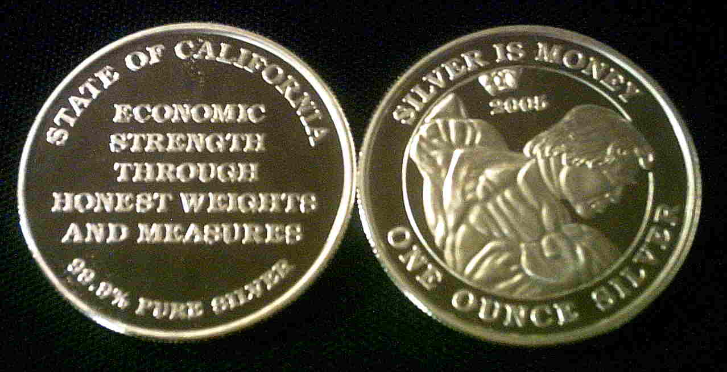
To further discuss this Silver Coin Proposal, contact:
Jason Hommel
Email: j@silverstockreport.com
http://www.silverstockreport.com

